**POWER BI**

**“SHOPNEST STORES SALES ”**

**Submitted By:**

**JEEVAN S**

**Submitted to:**

**TEAM SKILLOVILLA**

# 

**Introduction:**

ShopNest stands as the leading department store in the e-commerce marketplaces in Portugal, serving as a seamless link connecting small businesses from various regions to online channels. In today's dynamic business environment, the importance of data analytics cannot be overstated, particularly in enhancing decision-making and operational efficiency.

# **TOP CATEGORIES BY TOTAL PRICE**

**Question Statement :**

Identify and visually represent the top 10 product categories by total sales

**Visualization :**

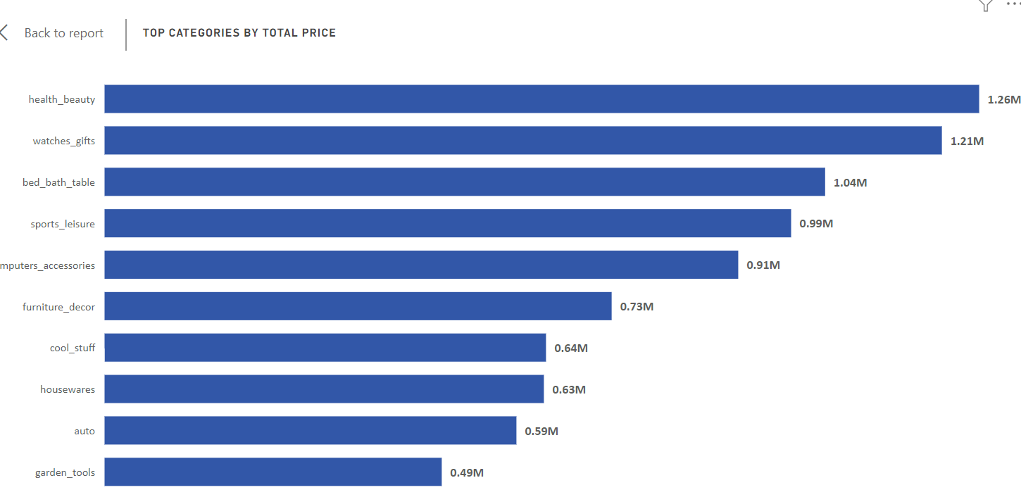

**Explanation :**

The bar chart showcases the top 10 product categories by total sales, revealing compelling insights into revenue generation.

Among these categories, Health beauty emerges as the top performer, boasting $1.26 million in sales, closely followed by Watches gifts at $1.21 million and Bed bath table at $1.04 million. Notably, Sports leisure and Furniture decor also exhibit strong performance, each surpassing $0.9 million in sales. Garden tools and Auto demonstrating sales figures of $0.49 million and $0.59 million, respectively.

The visualization underscores the significance of these top-selling categories, providing valuable guidance for strategic decision-making and resource allocation to capitalize on consumer preferences and maximize revenue potential. These insights into the top-performing product categories offer actionable intelligence for driving business growth and profitability. By leveraging this actionable intelligence, organizations can refine product offerings, tailor promotional campaigns, and nurture customer relationships to drive sustained business success

# **DELAYED ORDERS ANALYSIS**

**Question Statement :**

Determine the number of delayed orders in each category. An order is considered delayed if the actual delivery date is later than the estimated delivery date.

**Visualization :**

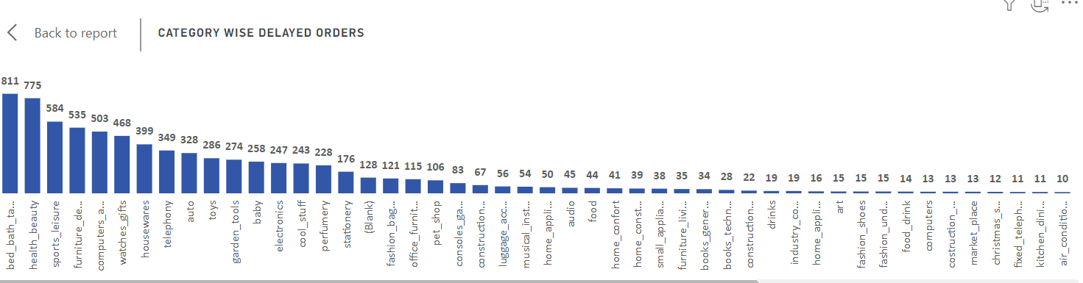

**Explanation :**Top of Form

The bar chart provides a comprehensive breakdown of delayed orders across a wide array of product categories, unveiling crucial insights into sales performance and fulfillment efficiency.

Notably, "Bed bath table" emerges as the category with the highest count of delayed orders, totaling **811**, indicating potential challenges in logistics and supply chain management within this segment. Similarly, "Health beauty" and "Sports leisure" exhibit substantial counts of delayed orders, with **775** and **584** respectively, highlighting the need for enhanced coordination and streamlined processes to meet customer expectations promptly. The analysis also reveals significant delays in categories such as "Furniture decor" (**535** delayed orders), "Computers accessories" (**503** delayed orders), and "Watches gifts" (**468** delayed orders), suggesting systemic issues that warrant immediate attention. In contrast, categories like "Diapers and hygiene" and "Flowers" demonstrate minimal instances of delayed orders, with only 1 each respectively, underscoring the efficiency in handling and prompt delivery within these product segments.

# **MONTHLY COMPARISON OF DELAYED AND ON-TIME ORDERS**

**Question Statement :**

Create a dynamic visual that compares the number of delayed orders to the number of orders received earlier for each month. Utilize the drill through cross-report feature to provide a detailed analysis of late and on-time deliveries.

**Visualization :**

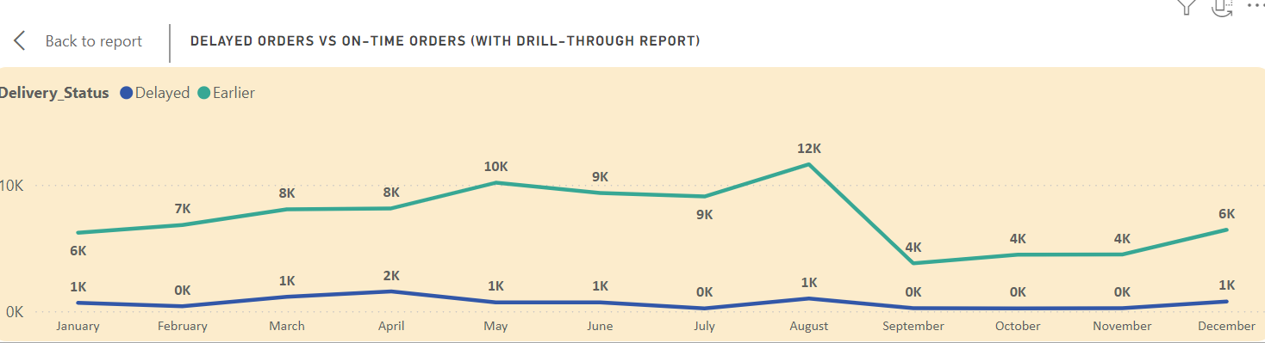

**Explanation :**

The line chart provides a detailed comparison of delayed and earlier orders across all months, offering valuable insights into order fulfillment performance throughout the year.

Notably, August emerges as the month with the largest disparity between delayed and earlier orders, boasting 11,620 earlier orders compared to a mere 996 delayed orders, showcasing exceptional efficiency in meeting customer demands. Conversely, July records the smallest gap between delayed and earlier orders, with 9,078 earlier orders slightly surpassing 216 delayed orders. The trend continues across the remaining months, with September showing 3,790 earlier orders against 231 delayed, October exhibiting 4,480 earlier orders versus 222 delayed, and November with 4,483 earlier orders compared to 245 delayed. These consistent findings underscore the organization's strong performance in fulfilling orders promptly.December and January witness increased delays, with 767 and 667 delayed orders respectively, potentially due to heightened customer demand during the holiday season. Conversely, June and May show relatively fewer delayed orders, with 691 and 696 delayed orders respectively, reflecting efficient order processing and logistics management during these periods.

# **PAYMENT METHOD ANALYSIS**

**Question Statement :**

Analyze the most frequently used payment methods by customers using a visually appealing representation, such as a pie chart or other suitable visuals.

**Visualization :**

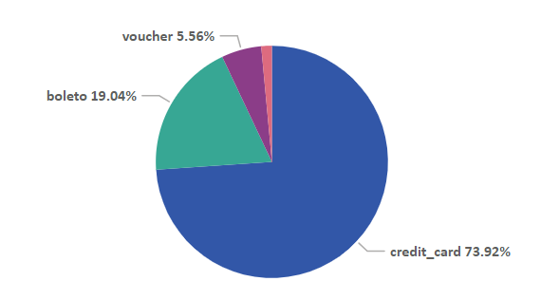

**Explanation :**

The pie chart offers a succinct overview of payment types and their distribution among customers, providing key insights into transaction preferences.

Credit card emerges as the most popular payment method, with 76,795 customers opting for this mode of payment, constituting the majority of transactions and representing approximately 73.9% of the customer base. Boleto follows as the second most preferred payment type, with 19,784 customers choosing this method for their purchases, accounting for around 19.0% of the total customers. Additionally, voucher and debit card transactions are represented by 5,775 and 1,529 customers respectively, indicating a smaller yet significant portion of the customer base utilizing these payment options, representing approximately 5.6% and 1.5% of customers respectively. Overall, the visualization highlights the dominance of credit card payments, suggesting a preference for convenience and flexibility among customers.

# **PRODUCT RATING ANALYSIS**

**Question Statement :**

Determine the top 10 highest-rated products and the bottom 10 lowest-rated products using a bar or column chart.

**Visualization :**

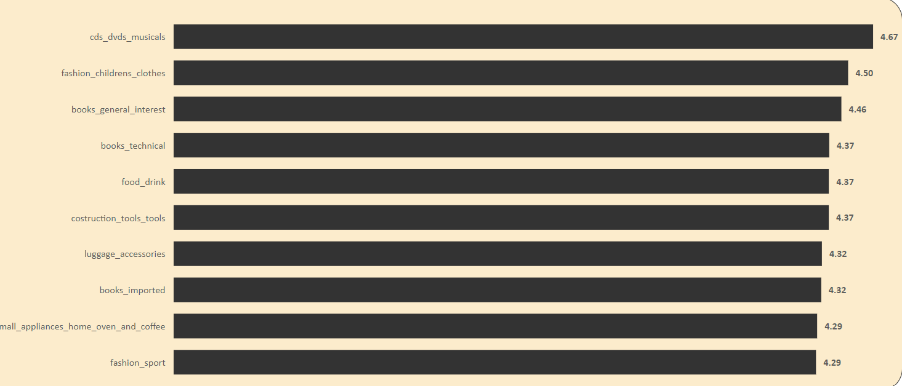

**Explanation :**

The bar chart presents a succinct overview of the top 10 highest-rated product categories based on average customer ratings, offering valuable insights into customer satisfaction and preferences. Topping the list is "CDs, DVDs, and musicals," boasting an impressive average rating of 4.67, indicating exceptional customer satisfaction within this category. Following closely, "Fashion children's clothes" and "Books general interest" secure the second and third positions with average ratings of 4.50 and 4.46 respectively, highlighting the high quality and appeal of these products among customers. Additionally, "Books technical," "Food drink," and "Construction tools tools" share similar average ratings of 4.37, underscoring consistent customer satisfaction across diverse product categories. Notably, "Small appliances home oven and coffee" and "Fashion sport" also garner commendable average ratings of 4.29, suggesting strong positive feedback from customers within these segments. The visualization underscores the importance of product quality and customer experience in driving overall satisfaction and loyalty.

# **STATE-WISE SALES ANALYSIS**

**Question Statement :**

Identify and visually represent states with high and low sales, providing a clear understanding of regional sales performance.

**Visualization :**

**Explanation :**

The map chart provides a comprehensive overview of sales performance across various states, highlighting notable variations in revenue generation. São Paulo (SP) emerges as the top-performing state, with sales exceeding $5.20 million, representing a substantial 38.3% of the total sales. Rio de Janeiro (RJ) follows closely, exhibiting considerable sales figures, with approximately $1.82 million in revenue, contributing significantly to the overall revenue at 13.4%.

Additionally, Minas Gerais (MG) and Rio Grande do Sul (RS) demonstrate noteworthy sales, with approximately $1.59 million and $0.75 million in revenue, respectively, comprising 11.7% and 5.5% of the total sales. Conversely, states such as Roraima (RR) and Amapá (AP) present lower sales figures falling within the lowest sales bucket. Roraima records sales of $0.007 million, while Amapá registers sales of $0.013 million, with each contributing less than 0.1% to the total revenue.

The map chart's gradient representation showcases states with high, medium, and low sales values, providing clear insights into regional sales trends. It underscores the dominance of key states like São Paulo and Rio de Janeiro in driving overall sales performance, while also highlighting opportunities for

# **SEASONAL SALES PATTERN**

**Question Statement :**

Investigate and visualize any seasonal patterns(Quarterly) or trends in sales data over the course of the year.

**Visualization :**

**Explanation :**

The combo chart provides a comprehensive overview of quarterly sales data across different years, offering valuable insights into sales performance over time.

The bar charts represent year-wise quarter-wise sales, showcasing distinct trends for each quarter. Notably, there is a clear upward trend in sales across all quarters, with significant fluctuations observed between different years. For instance, in the first quarter, sales surged from $0.71 Million in 2017 to $2.7 Million in 2018, indicating substantial growth year over year. Similarly, sales in the second quarter increased from $1.25 Million in 2017 to $2.81 Million in 2018, reflecting continued expansion and market demand. The line chart complements this analysis by illustrating the total sales for each quarter, providing a holistic view of overall sales performance over time.

# **REVENUE ANALYSIS**

**Question Statement :**

Determine the total revenue generated by ShopNest Store  and analyze how it changes over time(Yearly). Represent this information through suitable visuals to highlight trends and patterns.

**Visualization :**

**Explanation :**

The tree chart provides a visual representation of revenue trends across different years, offering insightful observations into revenue performance over time.

Notably, there is a significant increase in revenue from 2016 to 2017, with revenue soaring from $47k in 2016 to $6.92 Million in 2017, showcasing a substantial growth trajectory. This remarkable rise underscores positive market dynamics and the effectiveness of business strategies implemented during that period. Furthermore, the chart reveals a continued upward trend in revenue, with a notable spike to $8.45 Million in 2018, indicating sustained growth and continued success in revenue generation. This significant increase in revenue from 2017 to 2018 highlights the organization's ability to capitalize on opportunities and adapt to changing market conditions, ultimately driving robust financial performance.